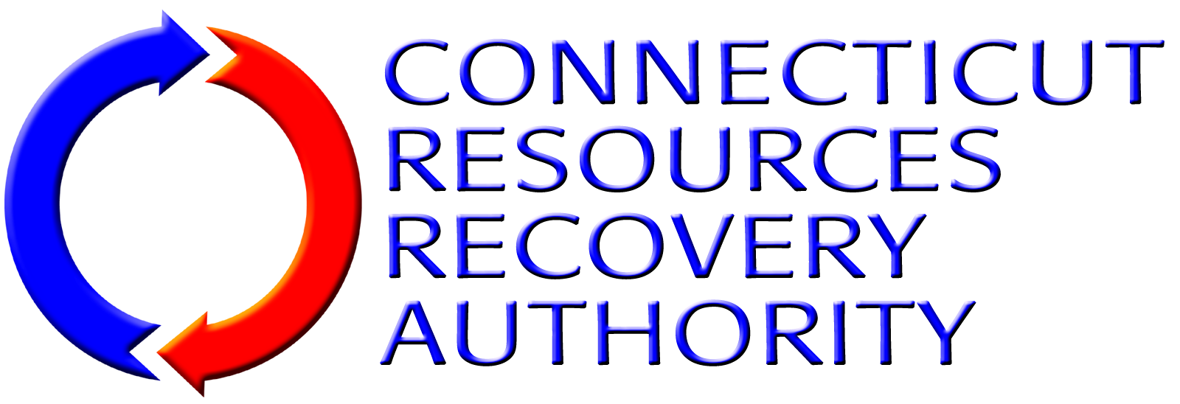
BUSINESS EXCEPTION FORM
Using this form (add additional sheets of paper as needed), Proposer shall identify any portion of the Work required or described in the RFP Package Documents, or any provision of the Agreement that Proposer desires to take exception to, including insurance, if any.
Proposer shall be specific regarding any exceptions listed. Proposer shall describe in detail the portion(s) of the Work or Agreement terms that the Proposer is taking exception to and why. Proposer shall also describe what, if any, alternative services, terms, or conditions Proposer is willing to provide or accept as a substitution for the Service, terms, or conditions to which Proposer has taken exception, if any.
If Proposer does not take exception to any portion of the Work required or described in this RFP Package Documents or to any terms of the Agreement, Proposer shall simply indicate below that Proposer “takes no exceptions”, and submit this form along with the other Proposal forms as part of its Proposal submittal.
Note that CRRA will negotiate with Proposer on only those items identified by Proposer on this Business Exception Form. Also note that revisions to the services or Agreement will be at CRRA’s sole discretion. Also note that pursuant to State of Connecticut statutes and regulations, the Agreement contains a number of provisions that CRRA, as a quasi-public entity, is required to incorporate in all of its contracts and are, therefore, non-negotiable.
Description of Exception Item |  | Reason for Exception | Proposed Alternative
1.
2.
3.
4.
5.
6.
7.

